Serial Killers? Investigating some Modernist myths about decoration, pattern and ornament through workplace interventions

Abstract
What is it about ornament that made it so contentious for influential Modernist thinkers and practitioners such as Adolf Loos and le Corbusier? According to Loos (1908) it was a sign of degeneracy, for le Corbusier best suited to ‘simple races, peasants and savages’ (1925). By championing the use of ornament as a vital tool for ‘resistance’ in the sense that Michel de Certeau used the word (1984; 1998) the practice-led research featured in this article seeks to interrogate some of these myths. Rather than being a passive adornment to an environment the visual artworks presented here tested the potential of decoration and ornament to offer a resistive, critical interruption to everyday spaces. The particular space addressed was that of the workplace, with bespoke artworks being made for three different work-related locations.

Keywords: decoration, ornament, pattern, art, intervention, everyday.

Introduction
What is it about ornament that made it so contentious for influential Modernist thinkers and practitioners such as Adolf Loos and le Corbusier? According to Loos (1908) ornament was a sign of degeneracy, for le Corbusier best suited to ‘simple races, peasants and savages’ (1925). Although the denigration of ornament within Modernist critique is well documented, the history of its suspicion goes back much further (see Ernst Gombrich, 1979, and Mark Wigley, 1995, for more detailed analyses). However, the views of these figures within early twentieth century culture reinforced for many of their contemporaries (artists, designers and architects) the impetus to seek new and ‘progressive’ visual forms that could signpost a new era: designs that were pared back and ‘pure’, unencumbered by the historical implications of the decorative. For Loos and le Corbusier, the ornamental had links to cultural and geographical identity, features they wished to deny in favour of what they considered to be a more universal and forward-looking aesthetic. By aligning the characteristics of ornament to peasants and savages, to women and degenerates, they signal it, by association, to be simple, backward-looking and therefore unsophisticated.

The practice-led research presented in this article seeks to interrogate some of these underlying attitudes. One of the primary aims was to investigate the extent to which decoration and ornament can indicate status and class in the workplace and, when used out-of-place, can critique these hierarchical indicators. Rather than being passive and superficial adornments to an environment the visual artworks made for this research tested the potential for decoration and ornament to offer a resistive, critical interruption to everyday spaces. I use the reference to resistance here in the same way that Michel de Certeau (1984 and 1998) used it: not in a way that is akin to revolution but resistance that is able to create a slowing down of momentum, used here to indicate an interruption to the usual way in which a place may be perceived. Thus, the artworks appear as interventions to spaces where such artworks would otherwise be unlikely to be seen and where the decorative and ornamental features of these appear incongruous to their surroundings. The particular space addressed was that of the workplace, with bespoke artworks being made for three different work-related locations: the financial service provider Aviva Plc., Berendsen Plc. - an industrial laundry - and, somewhat differently, the ordinary office chair.

Theoretical positioning and methods
Countering some of the assumptions made by Loos and le Corbusier, writers such as Clive Edwards (2011), James Trilling (2001, 2003) and David Brett (2005) demonstrate that decorative signs and symbols can reveal complex relationships between individuals and their surroundings, about the identity of groups and attitudes towards status. The semiotics of the artworks featured here were crucial to the way they were able to both highlight and offset the signs and symbols of their surroundings, whether this was through the repeated use of a specific motif or through the use of contrasting and incongruous materials.

A key theoretical reference was Pierre Bourdieu’s definition of class, particularly his terms ‘habitus’ and ‘field’. Bourdieu uses the term ‘habitus’ to describe an individual’s predispositions or preferences and demonstrates how these dispositions can position someone, and simultaneously also be shaped by, a person’s class. Bourdieu argued that it is the everyday choices of cooking, clothing, decoration, and so on that reveal the most deep-seated ‘dispositions’ that ‘forge the unconscious unity of class’ (Bourdieu 1977 and 1979). These dispositions are acquired through the various ‘fields’ that the individual encounters through a multitude of different relationships and social, educational or other interactions. As well as the fields of familial ties, school, college, university and work, Bourdieu also wrote extensively about areas of cultural production such as art, literature and music (Bourdieu 1993).

One of the reasons why Bourdieu is so useful here is his acknowledgment of the way that everyday materials, surfaces and the visual are key to his definition of class:

If a group’s whole life-style can be read off from the style it adopts in furnishing or clothing this is not only because these properties are the objectification of the economic and cultural necessity which determined their selection, but also because the social relations objectified in familiar objects, in their luxury or poverty, their ‘distinction’ or ‘vulgarity’, their ‘beauty’ or their ‘ugliness’, impress themselves through bodily experiences which may be as profoundly unconscious as the quiet caress of beige carpets or the thin clamminess of tattered, garish linoleum, the harsh smell of bleach or perfumes as imperceptible as a negative scent. (Bourdieu 1977: 77)

Here the habitus can be seen to affect conscious choices and opinions as well as less conscious habits and mannerisms such as a person’s accent or posture. Similarly, the sight and feel of particular materials create impressions that are both conscious and subconsciously felt. The impressions made by the use of particular finishes, surfaces and objects at work also signify the status and class of the individuals employed there. They help to put employees ‘in their place’.

Michel de Certeau continued the discourse around the everyday advocating the way that individuals use everyday means and materials to subvert, re-create, or alter what is around them (de Certeau 1984 and 1988). They do this in an effort to make more of what they have at their disposal, to circumvent problems or gain an advantage, often using creative means to achieve this. He refers to this as a form of ‘resistance’ (de Certeau et al 1988: 188) and to these practices as ‘tactical’ – they are interventions into the ‘strategic’ powers that shape and control our everyday.

Two key methods were used throughout this research – site-specificity and collage. Everyday work scenarios provided the settings for these artworks, the artworks being ‘collaged’ into each space either virtually through the making of paper and photoshop collages or through their physical insertion into the site. These strategies indicate a belief in practice or ‘praxis’ - a belief in the interconnectedness of practice and theory, of action and reflection that has the capacity for transformation (Friere 1993) as a way to explore theoretical positions. In his extensive examination of the everyday Ben Highmore finds that praxis is a key theme in attending to quotidian practices and that aesthetic strategies in particular are common to many of those who focus on this area. He describes the need for alternative practices to provide a mechanism by which the social can be examined through the everyday and identifies the practices of montage and collage as ways of giving the everyday that articulation. In this respect Highmore echoes de Certeau, whilst also drawing upon historical precedents in the work of the Surrealists and their use of montage in defamiliarising the everyday and in making strange what is otherwise overlooked.

Each of the bodies of work created for this research was made in relation to specific features of the location for which it was made. Extensive photographic documentation and written reflection upon each space was used to analyse the ways that status was evidenced through existing decoration and ornament. Consideration was given to what was missing from each site and how additional decorative and ornamental features could be used to raise awareness of existing hierarchies pertaining to status in each space. Though there is too little room to discuss them here in detail, the theoretical drivers for this part of the methodology included Robert Irwin’s analysis of different forms of site-relatedness within art practice (1985), Miwon Kwon (2004) and Claire Doherty (2004; 2009) on displacement.

There are precedents for the use of intervention in the expanded field of Illustration. These include the work of Linda Brothwell, for example, and her 'Acts of Care; the Lost Letters of Liverpool' in the UK. Where letters were missing from the front of iconic buildings of Liverpool Brothwell inserted handcrafted replacements made in brass. These were made using her own design and bespoke tools to form letters that combined English and Polish Wycinanki, a form of papercutting. The ‘Intervention/Decoration’ event that took place in Somerset in 2008 was organised by Foreground who invited a number of artists to make site-related decorative works that related to the context of the town of Frome. Exhibitors included Cornelia Parker, Eva Berendes, Lawrence Weiner and Richard Woods. There is also a precedent for the interaction of artwork and its placement in the workplace as seen in the practice of the 1960s Artists Placement Group (APG) (Bishop, 2012; Walker, 2002) and their assertion that the context is often half the artwork. However, unlike the APG the research described here proposes that the language of ornament and decoration can be used to foster a critical interpretation. To summarise, my research attempted to take both the decorative and the workplace as two factors that could create an interesting tension together.

Aviva Plc.
The first workplace I investigated was Aviva, one of the largest providers of life insurance, pensions and long-term financial services in the UK. At the time of my research Aviva had around 34 million customers and 36,000 staff worldwide. As a major supplier of house and life insurance in the UK it has very obvious links to the domestic, an aspect that for me enriched its potential as a site for decorative interventions. Through photographing the London head office I was able to understand its topography and identify the ways in which the architecture and interior décor of the building demonstrates status. In The Production of Space (1991) Henri Lefebvre refers to the inseparability of spatial and social relations, and the interconnectedness of power and space in the city. It was very easy to see here in Aviva the hierarchy of the company made evident in the materials and visual appearance of the building as well as the physical placement of staff, the CEO enjoying top floor views compared to workers in a windowless basement, for example.

As well as affording a way of exploring and revealing the site to me, photographs taken of the building provided a surface onto which I could explore ideas. Photocopies of these photographs were drawn or painted onto to explore alternative ideas for interventions (Figure 1). The drawings and sculptural assemblages generated for this research employ the method of combining two or more visual ideas together. ‘The radical practices of montage offer a vivid way of making the familiar strange, and it is this as much as anything that will offer something like a methodological base to this tradition of everyday life studies’ (Highmore 2002: 74).

Figure 1: Sarah Horton: Swag and Boardroom Décor (details from proposals for Aviva’s Head Office, London) 2012. Paint on paper. © Sarah Horton.

My chosen body of work for Aviva was a series of soft, portable sculptures collectively called “Let’s get comfortable” (Figure 2). These artworks established a relationship with the chairs, floor and walls of Aviva’s reception areas and provided a visual and physical disruption of these spaces. Each piece employed signifiers that connote the complex relationship between the home and the workplace. The choice of very specific materials, colours, forms and patterns allude to notions of value and status as related to the furniture and décor witnessed in this building.

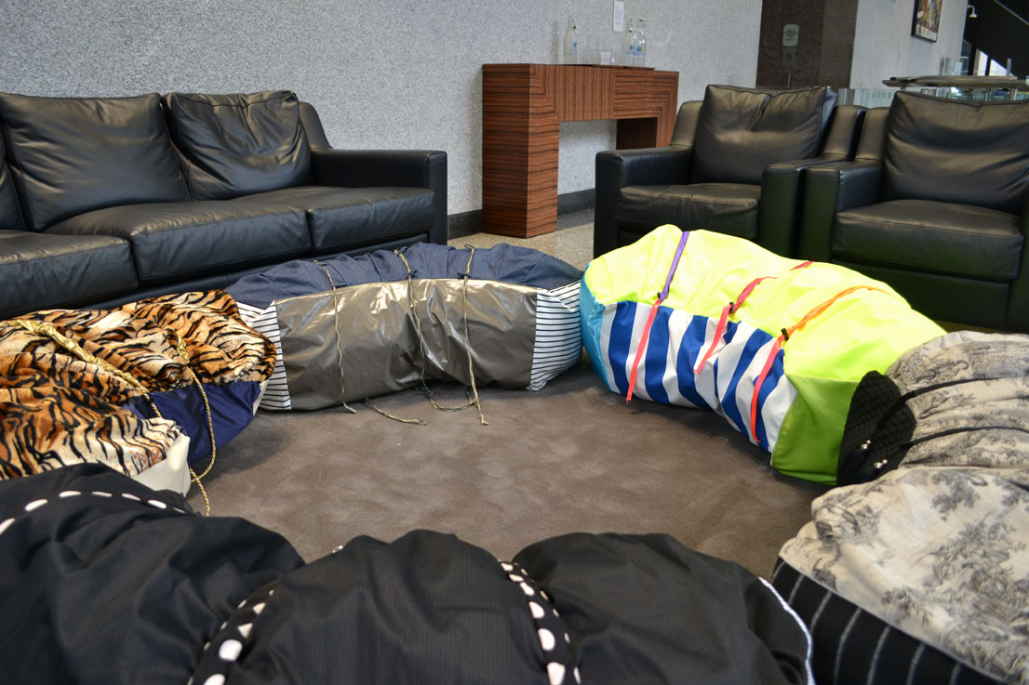
Figure 2: Installation of “Let’s get comfortable” in Aviva’s Head Office, St. Helen’s, London (2013). Five sculptures each made of fabric, cord, cord stoppers, hollowfibre filling and additional embellishments, placed on and around the furniture in various configurations. Each piece approx. 140cm long x 23cm depth x 23cm height. © Sarah Horton.

Clive Edwards identifies the following functions of decoration and ornament: ‘a) representing collective identity, b) signifying place, c) creating distinction, d) being a symbol of society, group, etc., e) personalizing space and f) aiding orientation’ (Edwards 2011: 185) some of which inevitably overlap and are recognisable in the writings of Ernst Gombrich (1979) and James Trilling (2001; 2003). In his book Rethinking Decoration (2005) David Brett states his aim to restore the ornamental, decorative and pleasurable with what he calls ‘theoretical dignity’ (Brett 2005: 1). His is a broad study of decoration, examining it not just for its aesthetic value but also for its psychological, perceptual and social values.

The semiotics of “Let’s get comfortable” makes use of a number of these functions. The different types of fabric associated with leisure and/or home furnishings allude to place, but these signifiers placed out-of-context, away from home, give the pieces a potency they otherwise wouldn’t have. Denim, for example, in its capacity to hint at leisure and personal space along with upholstery fabric that would be more fitting in the private sphere rather than the public, corporate counterpart, disorientates the viewer and reminds them of their identification with home.

The main component of these sculptures is fabric, with other embellishments such as cord and cord stoppers, ribbons or elastic. Yee and Gustafson refer to upholstery fabrics as ‘extensions of clothing that dress the room. Like clothing it is a clue to character’ (Yee and Gustafson 1983: 212). This link to clothing is one of a number of ways in which these pieces relate to the body and of the importance Bourdieu places on the body in its expression and experience of habitus. Secondly, the pieces invited touch, either through the tactile quality of the materials, through the suggestibility of the cords/cordstoppers or through other fastenings such as the braces. Thirdly, the slight crescent shape of the sculptures gave them the capacity to curve around the body of the user.

Unlike the rather sterile furniture at Aviva these soft sculptures all used an individual design, each of them themed in some way. For example, the piece seen in Figure 3 is very loosely based on the suit, using cotton striped shirt and pinstriped suit material in combination with braces so that the sculpture could be handled and re-shaped. The pinstripe used is a pattern that in clothing unites a social group as a sign of industry and commerce. Usually an understated or subtle stripe, the earliest examples of stripes in the business suit have been in evidence from the second half of the 18th century. Alastair Sooke (2011) describes the suit as both a fashion item and a uniform and although the pinstripe straddles the worlds of business and leisure it will usually place the wearer in the context of the workplace. The channels were made of polka-dot silk (a flourish that might be seen in a necktie) and threaded through the silk is red elastic with metal brace clips at the ends. The surface details of the sculpture provide semiological links to the workplace in contrast with its cushion-like form and shape. This allows the piece to straddle the domestic and the place of work to hint at labour, luxury and leisure, all three of which are bound up in issues around class and status.

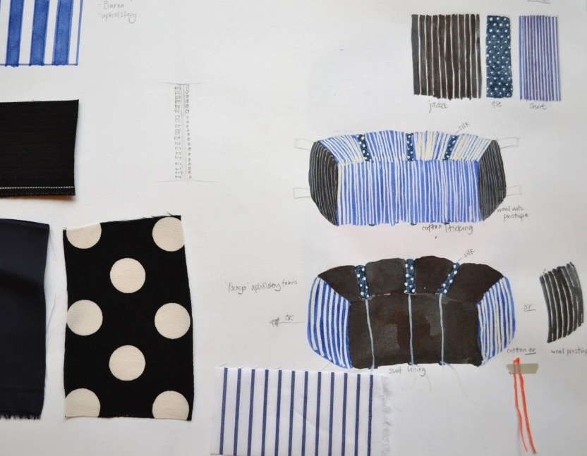 | 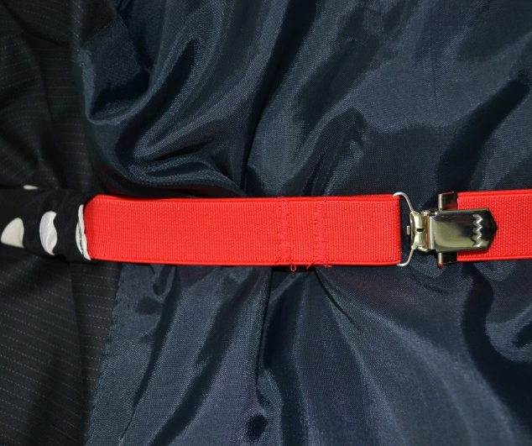
Figure 3: Preparatory designs, fabric samples and detail of “Let’s get comfortable” (2013). Cotton, polyester, silk, elastic, braces. © Sarah Horton.

Each of the other sculptures also employed pattern, decoration and ornament as specific signifiers. One is loosely based around the colours of office stationery – of highlighter pens and post-it notes - and another on home-furnishings, and so on. Thus, in addition to the pliability of the artworks, these details give each a particular character. The piece using denim, for example, also incorporated a white and blue striped sweatshirt fabric (often used in Breton t-shirts) and tape threaded through ‘belt’ loops. Originally designed for workwear in the 1870s, the widespread wearing of jeans stemmed from a surplus of WWII utility wear (Bonami, Frisa and Tonchi 2000) and now denim is more readily associated with leisure. The portability of these pieces is evocative of the beanbag or cushion which is one of the strongest signifiers of leisure connected to furnishings. The association with the beanbag and the use of home furnishing or clothing fabrics highlights the potential polarisation of work and leisure.

Figure 4 shows a visitor sat alongside the pieces at Aviva. I enjoyed this quietly subversive invasion into such a space of financial prowess.

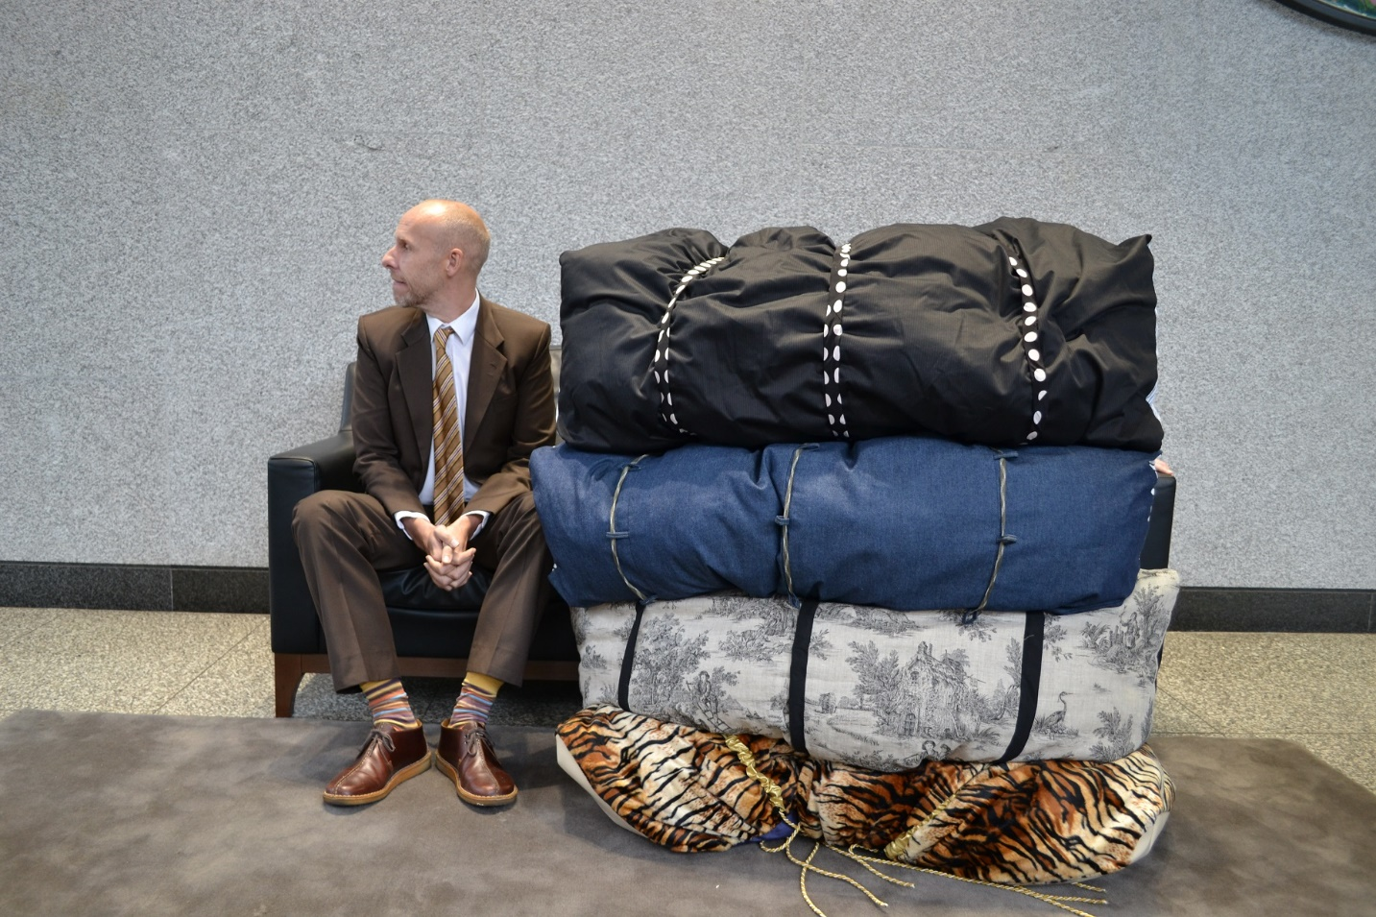
Figure 4: Visitor to Aviva with “Let’s get comfortable” (2013). Cotton, polyester, silk, ruched elastic, cord, cord stoppers, toggles. © Sarah Horton.

Berendsen Plc.
Stemming from an interest in the heaps of fabrics made for the Aviva pieces I began to look for factory spaces that either manufactured or serviced cloth, which led me to make contact with Berendsen Plc. Berendsen (now ‘Elis’ https://uk.elis.com/) is a European textile service business that, at the time of undergoing this research, employed 9,000 staff working at 60 sites in the UK. The laundry at Fakenham in Norfolk (formerly called ‘Sunlight’) employed 140 staff in a purpose-built two-storey building housing a large factory floor plus two open plan offices and a retail dry-cleaning service that also serves as the reception area for visitors. It was processing up to 450,000 pieces each week. These included tea towels, table cloths and floor mats, as well as work garments - chef whites, high-vis jackets and overalls.

During my initial visits to Berendsen I became aware of the lack of natural daylight in the factory and it was this that prompted the use of the cloud as a motif for making new art work. The cloud also became a symbol for daydreaming, of freedom, a space for projecting thoughts, or pretending to be somewhere else. As with Aviva I began with the process of drawing and painting using the photographs I had taken (Figure 5). In these I painted clouds onto overalls being paraded through the factory on a suspended conveyor belt or cloud shapes painted into a puddle on the floor. In these collages I proposed the idea that the cloud motif could disturb the rationality of the white, ‘clean’ interior. If the whole of the space at Berendsen were seen as a surface on which to hold the pattern of the cloud, could this decoration/ornamental covering, introduced in various places in the laundry, be a way of covering something both physically and maybe even politically to introduce an element of visual disruption that would raise questions for those working there about the nature of their workplace and the repetitious activities undertaken within it? Could the pattern and the colour activate the space, the shapes and forms shifting and altering across the space, much as the clouds themselves move across the sky?

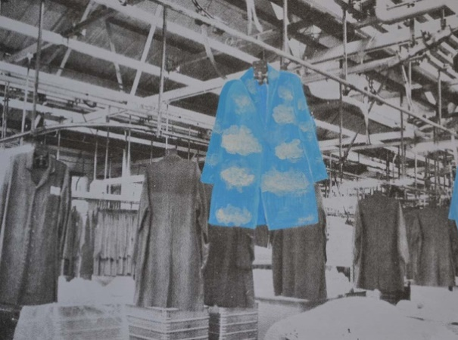 | 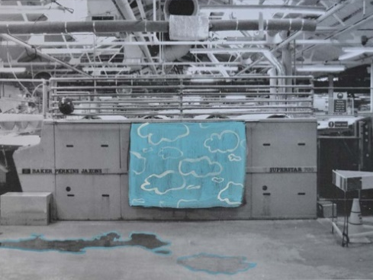
Figure 5: Proposal drawings for Berendsen (2014). Pencil and gouache on photocopy. © Sarah Horton.

Matthew Witkovsky writes that ‘It is pattern………that determines intelligibility in a system; …. [but] it is fantasy that shapes the character of the truly meaningful patterns in human creativity’ (Witkovsky 2013: 47). In these initial experiments it is the fantasy property of the cloud pattern that was used to disrupt the systems to undermine the intelligible order of the laundry.

In his book Rethinking Decoration: Pleasure and Ideology in the Visual Arts (2005) Brett describes in detail three historic categories of objection to the decorative, one of which involves a preference for plainness of language (whether visual or spoken), of straightforward rhetoric rather than the ‘guile’ of florid speech that is at times associated with decoration (Brett 2005: 184). These categories come together, as Wigley (1995), Gombrich (1979) and others have attested, where decoration has been eliminated in many religious and cultural contexts in favour of the apparent purity of the white wall. In these situations the decorative is perceived as a form of dirt or contamination to be white-washed over. This is where the ‘otherness’ of these works of art in the context of the workplace came into effect, in their unfamiliar presence there. Ornament has no place or function in the laundry because the decorative and ornamental is usually associated with pleasure, whilst the workplace is associated with industry. Thus it is this reassertion of pleasure through the ornamental that affords these artworks another potential way to disrupt and at the same time to reconcile the often polarised spheres of leisure and work.

Six pieces were ultimately selected and positioned at various locations in Berendsen, all of which incorporated the image of the cloud. The cloud is often referred to as a type of shape-shifter, a pareidolic screen for the perception of all kinds of imagined images. The use of the cloudscape across a number of locations (Figure 6) was a hint at the changing nature of the cloud across the sky, as well as a metaphor for the bundled laundry as it is sorted, cleaned and pressed through the many different processes it encounters. The cloudscape featured on a large silk hanging in the main factory floor of the laundry, and as two singular, oddly configured shapes in the factory floor and reception area. In the office the cloudscape was visible as ‘wallpaper’ on the side of a filing cabinet and adjacent to an ideas board (blue-sky thinking being the reference here, as well as to the cloud as a form of data storage), and in the showroom as a printed alternative to a hi-vis jacket. Finally, a single outline of a cloud was made in neon and placed in the stairs that lead to the staff canteen and toilets.

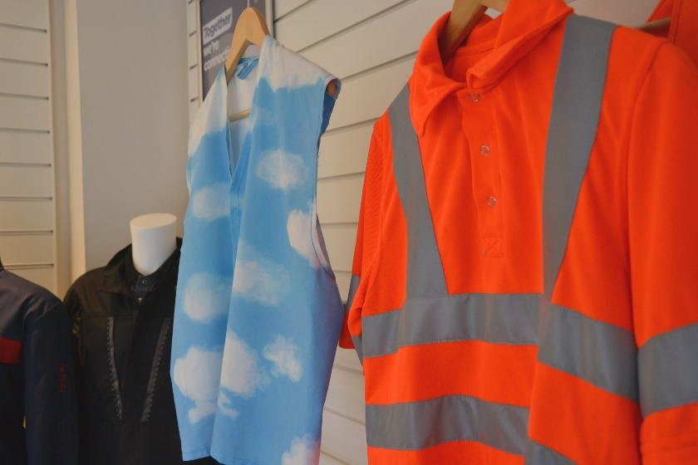
Figure 6: Top Left: Cloud Busting (2014), digital print on acrylic. Installed on the main laundry floor, Berendsen.
Top Right: Dream Cloud (2014), neon. Installed on the main staircase, Berendsen.
Bottom Left: Head in the Clouds (2014), digital print on vinyl installed in the office, Berendsen.
Bottom Right: Could (2014), digital print on fabric. Installed in the showroom, Berendsen.
All photographs © Sarah Horton.

Malcolm Miles writes that decoration is a way of making ‘narratives visible ... to open a space for conversation where such possibilities are generally closed’ and that ‘(d)ecoration is not a process of purification but of accretion and deconstruction, in the terms of the dominant city a kind of pollution or dirt. Endlessly diverse and always contingent, decoration undermines the ideal’ (Miles 2000:5). These pieces might be said to be contaminants in this workplace. Alternatively, I thought of them as visual apertures – virtual punctures to the appearance of the factory. These were apertures that the viewer could project her/his thoughts and daydreams upon. They were reminders of another space whether this was real or imagined. The contrast of seeing the cloudscapes in this industrial space – their difference - was seen as a form of resistance:

The ‘resistance’ of the everyday (de Certeau’s leitmotif) is a resistance born of difference, of otherness: bodies that are at variance to the machines that they operate; traditions that are unlike those being promoted; imaginings that are different from the rationale governing the present. (Highmore 2002: 148)

The office chair
In 1994 Doreen Massey wrote that

‘(t)he spatial … can be seen as constructed out of the multiplicity of social relations across all spatial scales, from the global reach of finance and telecommunications, through the geography of the tentacles of national political power, to the social relations within the town, the settlement, the household and the workplace.’ (Massey 1994: 4)

The third site for my interventions was the office chair, as much a product and tool of spatial construction as the factory or the high-rise office. A set of chair interventions were displayed in an exhibition entitled Disruptive Decoration in Norwich University of the Art’s EAST Gallery. This was obviously a far more conventional space for installing artwork, but it was also – unlike the other locations – my own workplace.

Chair interventions have featured in my practice for some time and these very mundane, everyday office chairs presented an opportunity to test new ideas. These are sculptures mounted onto or taking over the type of chair that could just as easily be found in the office at home as in the offices at Aviva. I wanted to create sculptural interventions that might again reference the domestic in their choice of materials but would also playfully frustrate the functionality of the chairs as seen in the piece Almost Every Cushion in the House (Figure 7). I was also keen to avoid a simple binary positioning of the work and of home as the home is not always a place for leisure. (I’m thinking of the use of the home for paid employment such as piece work, but also the significance of domestic work which often goes overlooked and unappreciated as labour.)

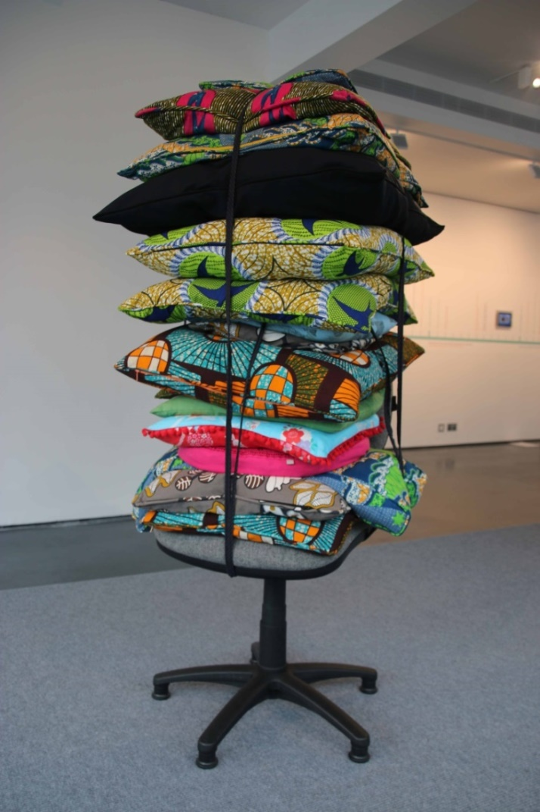
Figure 7: Almost Every Cushion in the House (2016). Office chair, various fabrics, wadding, cushion pads, zippers, piping. Height approx. 200cm. Photographed in the Disruptive Decoration exhibition at EAST Gallery^{NUA} Photograph © Denisa Ilie.

The chair interventions played with the relationship between the functional and dysfunctional. This play was significant because the artworks reference our everyday experiences of the decorative and décor, much of which has a utilitarian purpose. Working on the borders between art and design whilst exploring aspects of functionality can usefully question the context of consumption, value and display.

Gombrich recognises decoration as a sign of value or elevation in many contexts, including Indian temples, Moorish palaces and Gothic cathedrals (Gombrich 1978: 17). Decoration is a sign that something is to be enjoyed visually, is adorned and thus venerated. Decoration and ornament can therefore equal value, and the labour or craftsmanship associated with its production has been seen to indicate a labour of devotion and dedication. The piece Dreaming of Versailles (Figure 8) used a stainless steel frame covered by a frilled fabric piece that was again made to fit the office chair. Its dimensions allow it to balance on the seatpad of the chair, the steel skeleton offering a form of prosthetic extension and a means of supporting the softer outer layer, much as our bodies support our skin or our clothes. This ‘re-dressing’ of the chair with layers of fabric that were painstakingly painted and stitched together demonstrate a degree of care and regard, a lengthy level of particularity and crafting that alters the general sameness of the mass-produced chair. This is a reference to different types of labour, to the haptic and to the material, as much as the immaterial that is suggested through the office chair itself.

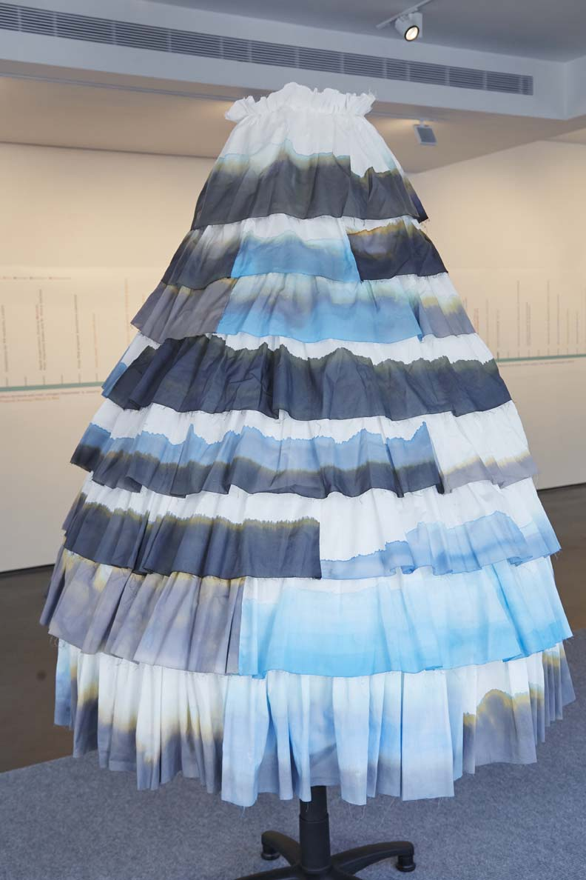 | 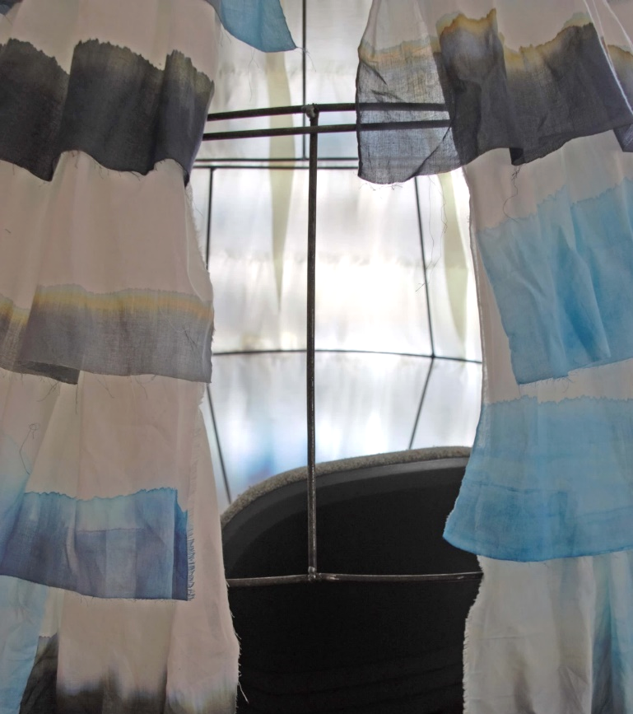
Figure 8: Dreaming of Versailles (2016). Office chair, hand-painted cotton, steel, ribbon. Height approx. 200cm. Photographed in the Disruptive Decoration exhibition at EAST Gallery^{NUA}. Photographs © Denisa Ilie.

The piece 24-7 (Figure 9) refers very directly to my own home environment, the juggling of family and work responsibilities and the difficulty of separating these two. The incorporation of patterned fabrics includes those used for making my own clothes or clothes for my daughters or for various sculptures I have made over the years and indicate a conflation of home and work. The patchwork-like presentation of these small scraps of fabric creep through the piece like a timeline. The bulk of the piece weighs heavily on the chair: on the one hand it could be said to be enveloping and ‘comforting’ it but on the other hand it could be smothering it. The large expanse of silk-like fabric pools on to the floor like a puddle of spilt ink. As with the earlier “Let’s get comfortable” piece at Aviva the use of denim in the upper part of the work is a material that signifies both workwear and leisurewear.

In all, the use of the different fabrics, the shape, weight and form of each piece, and the ambiguity of meaning in the way each of these aspects communicate make a single interpretation of the chair interventions difficult. Their indeterminacy is designed to provoke the viewer to consider for themselves what each might mean for them. To some extent they attempted to reconcile oppositional aspects of work and home environments, for example by offering softness to balance hardness, the playful to offset the severe or austere, the bespoke with the mass-produced and so on. The additions to the chair can be seen to provide something that is at times missing in the work environment – the sensual and pleasurable. This enriching of the workplace again echoes Myerson’s research into office design and how some companies see value in enhancing the workplace to include psychological as well as physical and functional comfort (Myerson 2014).

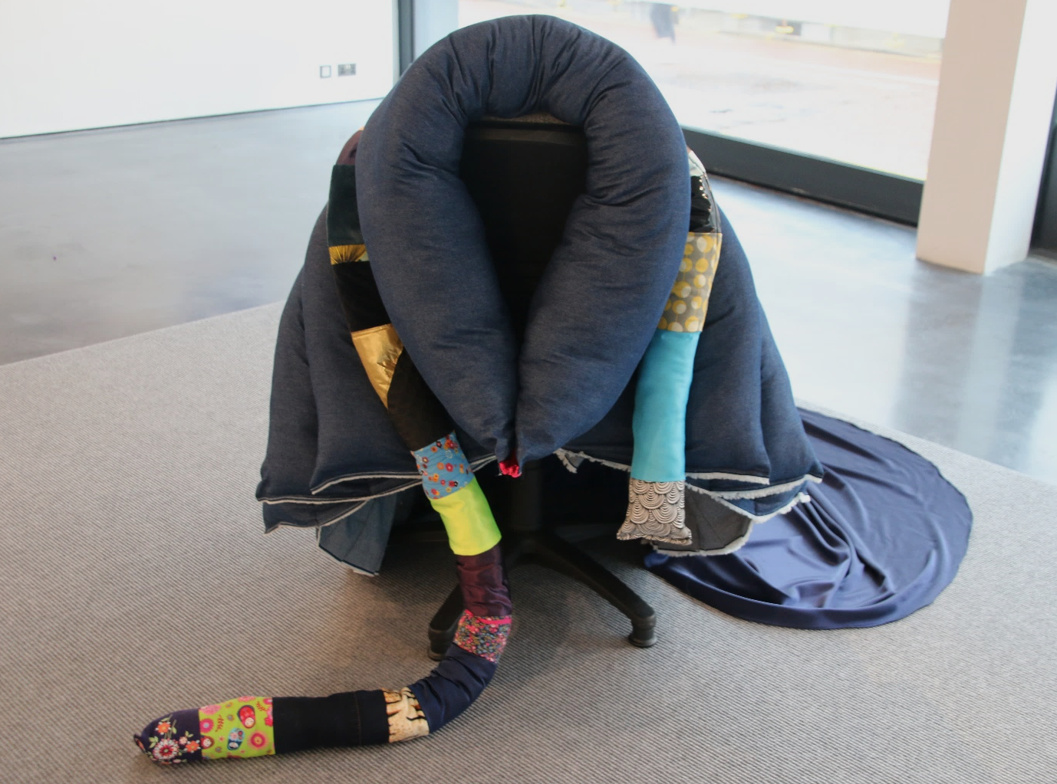
Figure 9: 24/7, 2016. Office chair, various fabrics, wadding, zipper. Approx. 100cm high x 200cm across. Photographed in the Disruptive Decoration exhibition at EAST Gallery^{NUA}. Photograph © Sarah Horton.

Discussion
The primary audiences for these artworks were the employees working at Aviva and Berendsen and, in the case of the office chairs displayed at EAST Gallery^{NUA}, all visitors to the gallery. The audience at Aviva and Berendsen viewed these pieces of art against the backdrop of their everyday work setting. To experience them like this was to view them within the environment for which they were designed, such that the signifying references in the art - the materials used, the construction, the symbolic and metaphorical properties - would be appreciated alongside a familiarity with the viewers’ very specific labour conditions.

Aviva was the first of my interventions and on reflection I wish I had found ways to gather more feedback about the presence of “Let’s get comfortable”. What I did observe was that the sculptures prompted conversation: employees and visitors to Aviva would point to them, comment on them, sometimes laugh. At least two visitors said they wanted to play with them and others adjusted them in order to sit against and lean into them. These acknowledgements of the playful and/or comfortable qualities of the works suggest to me that the sculptures were able to play a positive role despite their incongruous appearance. On one occasion these sculptures were pushed underneath the sofas and, on another, two were apparently taken to the top floor of the building and placed in the CEO’s reception area. Retrospectively I regret not having more documentation of the latter. My limited documentation of the visual and oral aspects of the Aviva works in-situ was certainly a shortcoming here.

The feedback about the Berendsen works was gathered in a more structured way and although some of this feedback was directly related to the works themselves there was also an element of the works prompting discussion in the same way that I had previously seen at Aviva. Both the cloud motif and the issues around labour emerged as topics for discussion. Employees talked with me about changes to the environment at Berendsen, about physical alterations in the main laundry and also to ‘efficiencies’ that had led to redundancies or diminutions to roles. Another employee described their frustration at not being able to get a doctor’s appointment at a time that would fit outside work hours. Workers also described the way in which the cloud motif reminded them of flying, or that they would rather be somewhere other than at work. In a simple tally chart the neon piece Dream Cloud was the most popular of the works and interestingly was the one work that the manager asked if he could retain as a permanent fixture.

Looking back, I perhaps could have gone further in my interventions at Berendsen and been more adventurous. The chair sculptures offered a chance to be more extreme. With regard to the exhibition at EAST Gallery^{NUA} in which they were exhibited, one visitor (a senior lecturer employed by NUA) described it as ‘gaiety combined with corporate haunting’ and recognised the echo of the shape of the carpeted plinth with a boardroom table elsewhere in the building. The curator of the gallery commented that the invasions of the chairs made such chairs seem dull and characterless and had prompted her to think about her own office as stark and functional. She also made the comment that it is unusual to see the artist herself installing the work which was, to me, evidence of the broader labour of the artist that falls outside of the making of the pieces. A student visiting the show described the chairs as ‘victims’ of an infiltration, and another visitor iterated that there is ‘something unnaturally sterile about the office environment and the soft and squishy domestic sphere is a threat to this’.

The experience of placing work in all three of these environments opened up discussions about art, the nature of Ph.D. study and research and how the employees themselves engaged with art. Employees would tell me about the kinds of exhibitions they see, if any, or the types of creative endeavours they have undertaken at home or in their own education. On more than one occasion there was debate about the extent to which people are ‘naturally’ creative. These discussions about art, about employment and employers, even about local doctors, remind me of Henk Slager’s assertion that context-responsive practice should connect ‘the material conditions of location, the discursive network, and the prevailing modes of criticality, while articulating the site as a differential place and medium’ (Slager 2012: 43).

The experience of the ornamental in the context of the work environment recalls Brett’s argument that pleasure experienced through the encounter with the decorative is able to connect the individual to a wider social sphere. Trilling similarly argues that ornament can be a bridge between cultures and between strains within the same culture (Trilling 2003: 3). What I had underestimated was that by presenting singular, bespoke works in the environment of the mass-produced these artworks provided a vehicle for dialogue, either between myself as the artist and the staff who worked in these locations or between the staff themselves.

Bourdieu’s assertion that the habitus is reinforced through the workplace (among many other fields) was clearly evident in Aviva and Berendsen where the status of the employees was underlined through the very stuff that surrounded them. Whilst the CEO of Aviva may have an impressive collection of original contemporary artworks adorning his office walls, the bank of workers placed both physically and symbolically in the lower echelons of the company make do with minimal decoration, with only a smattering of personal ornaments or photographs, for example, in their workstations. In the context of this 1960s International Style high-rise office the ‘efficiency’ of the modernist model that Loos so keenly advocated is very much alive. In Berendsen the hierarchy was slightly different but still evidenced in the material conditions (Slager 2012) of the workers: the walls of the offices, for example, were painted and used to display prints whereas the main laundry walls consisted of bare concrete.

Returning to Brett’s objective to afford to ornament and decoration their theoretical dignity this body of work was intended to do this through various strategies. Firstly, they utilized the strategies of guile and pleasure, two of the qualities that critics have levelled at decoration over the years. Their guile could be seen in the way they were placed, their presence being an unnecessary extravagance in these utilitarian locations. Whether through pictorial intervention demonstrating a conceptual interruption of expectations as seen in Figure 1, or through the sculptural pieces, both use simultaneous references to symbols and materials that are more usually understood in other contexts to provide new thoughts for a particular location. Thus the degree of intervention varied and calls to mind Rosalyn Deutsche’s distinction between the assimilative and interrogative models of site-related art; the first – assimilative - model, would insinuate work into a site, in a non-challenging way that sits at ease within its environment. The second model would place work that somehow offers a more challenging and potentially uncomfortable relationship with its surroundings (Deutsche 1996). She gives the example of Krzysztof Wodiczko’s Homeless Projection: A Proposal for the City of New York, a site-specific work where the artist projected images of the homeless directly onto the monuments in Union Square. By doing so Wodiczko appropriated the monuments with images of the homeless, thereby revealing marginalised groups and raising socio-political issues around land ownership and redevelopment. Perhaps in the light of this model my Aviva and chair works were more interrogative and the Berendsen pieces more assimilative. Either way, the pieces presented in this article worked by straddling certain dichotomies – leisure and industry, home and work, craft and mass production - and the extent to which they provided more or less ‘friction’ within these environments.

Conclusion
Through creative practices de Certeau writes that the individual can ‘patiently and tenaciously [restore] a space for play, an interval of freedom, a resistance to what is imposed (from model, a system or an order)’ (de Certeau, Giard and Mayol 1998: 255). The artworks made for this research performed a dual role in busting the myth that ornament is passive and redundant. On the one hand they presented a disruptive function in the work environment: installing artworks at Aviva and Berendsen and even on the office chair provided a means of contesting the workplace through decorative and ornamental interventions, by breaking up the uniformity of spaces and by introducing visual elements that were not essential to operational efficiency.

On the other hand, these works were able to suggest connective and ameliorative properties. By presenting singular, bespoke pieces in the environment of the mass-produced, these interventions provided a vehicle for conversation and dialogue, not only a dialogue with the interior design but also between the artist and the staff who work in these locations and between the staff themselves. Ornamental features were able to make connections between the often polarised spheres of work and leisure and the employment of decorative materials and motifs could be seen to restore visual and haptic connections to the body at work. It is possible that by witnessing these visual interventions staff were able to think about the value of their own labour and work environment in a different way.

6332 word count (includes figure captions but not the Abstract)

References
www.aviva.com (accessed 22.4.2019)
Bishop, Claire. (2011), Artificial Hells: Participatory Art and the Politics of Spectatorship. London: Verso.
Bonami, Francesco, Frisa, Maria Luisa and Tonchi, Stefano (2000) Uniform: Order and Disorder. Milan: Edizioni Charta.
Bourdieu, Pierre. (1979), Distincion: A Social Critique of the Judgement of Taste translated by Nice, R. (1984). London: Routledge & Kegan Paul Ltd.
Bourdieu, Pierre (1977), Outline of a Theory of Practice translated by Nice, R. (1977). Cambridge: Cambridge University Press.
Bourdieu, Pierre (1993), The Field of Cultural Production: Essays on Art and Literature. New York: Columbia University Press and UK: Cambridge University Press.
Brett, David (2005), Rethinking Decoration; Pleasure and Ideology in the Visual Arts. New York: Cambridge University Press.
https://www.lindabrothwell.com/portfolio/acts-of-care-the-lost-letters-of-liverpool/ (accessed 20.9.2019).
Brüderlin, Michel (2001), Ornament and Abstraction. US: Yale University Press.
Collins Concise Dictionary (1995), Glasgow: HarperCollins Publishers.
https://en.contextishalfthework.net/ (accessed 22.4.2019).
De Certeau, Michel (1984), Practice of Everyday Life. Berkeley: University Of California Press.
De Certeau, Michel, Giard, Luce and Mayol, Pierre (1998) The Practice of Everyday Life Vol. 2 Living and Cooking. Minneapolis and London: The University of Minnesota Press.
Deutsche, Rosalyn (1996), Evictions: Art and Spatial Politics. Cambridge Massachusetts: MIT Press .
Doherty, Claire (2004), Contemporary Art: From Studio to Situation. London: Black Dog Publishing
Doherty, Claire (2009), Situation. UK: Whitechapel.
Douglas, Mary (1984), Purity and Danger: an Analysis of the Concepts of Pollution and Taboo. London: Routledge.
Edwards, Clive (2011), Interior Design. A Critical Introduction. Oxford, UK: Berg.
eFIG (nd) https://plantsatwork.org.uk/images/PDFs/PPP_leaflet1.pdf (accessed 22.4.2019)
https://uk.elis.com/ (accessed 22.4.2019).
Freire, Paulo (1993), The Pedagogy of the Oppressed. London: Penguin.
Gombrich, Ernst (1979), The Sense of Order: A Study in the Psychology of Decorative Art. UK: Phaidon Press.
Highmore, Ben (2001), Everyday Life and Cultural Theory. London: Routledge.
Highmore, Ben (2002), Everyday Life Reader. London: Routledge.
Irwin, Robert (1985), Being and Circumstance: Notes Toward a Conditional Art. California: Lapis.
http://foregroundprojects.org.uk/projects/intervention-decoration/ (accessed 20.9.2019).
Kwon, Miwon (2004), One Place After Another: Site Specific Art and Locational Identity. Cambridge, Massachusetts: MIT Press.
Le Corbusier (1925), The Decorative Art of Today translated by Dunnett, J. Massachusetts: MIT Press
Lefebvre, Henri (1991 [1974]), The Production of Space. Oxford: Blackwell .
Loos, Adolf (1908), ‘Ornament and Crime’ in Opel, A. (ed.) (1997), Ornament and Crime: Selected Essays translated by Mitchell, M. UK: Ariadne Press.
Massey, Doreen (1994), Space, Place and Gender. Minneapolis: University of Minnesota Press.
Miles, Malcolm (2000), The Uses of Decoration: Essays in the Architectural Everyday. UK: John Wiley & Sons Ltd.
Myerson, Jeremy and Privett, Imogen (2014), Life of Work: What Office Design Can Learn From the World Around Us. UK: Black Dog Publishing.
Nierhaus, Irene (2009), ‘The Modern Interior as the Geography of Image, Space and Subject’ in Sparke, Penny (2009), Designing the Modern Interior: from the Victorians to Today. Oxford and New York: Berg.
Slager, Henri (2012), ‘Context-Responsive Investigations’ in Dombois, Florian; Bauer, Ute Meta; Mareis, Claudia and Schwab, Michael (eds.) (2012) Intellectual Birdhouse: Artistic Practice as Research. London: Koenig Books.
Sooke, Adrian (2011), The Perfect Suit. [DVD] BBC4.
Trilling, James (2001), The Language of Ornament. London: Thames and Hudson.
Trilling, James (2003), Ornament: A Modern Perspective. Seattle and London: Univ. Of Washington Press.
Walker, Jonathan (2002), Left Shift: Radical Art in 1970s Britain. London and New York: I.B. Tauris and Co. Ltd.
Wigley, Mark (1995), White Walls, Designer Dresses: the Fashioning of Modern Architecture. Cambridge Mass: MIT Press.
Yee, Roger and Gustafson, Karen (1983), Corporate Design: The Interior Design and Architecture of Corporate America. London: Thames and Hudson.

Acknowledgments
I would like to acknowledge staff at Aviva’s head office in London and the Norfolk branch of Berendsen for allowing me to photograph and install work in their premises.

As the etymological root of the terms ‘decoration’ and ‘ornament’ are both closely linked (Collins 1995) I have used these words interchangeably as co-conspirators in this resistive endeavour.
Of course, there are exceptions to this general rule as some forward-thinking employers have begun to see the benefits to productivity of improved workplace design. See Myerson (2014) for example, as well as Wineman (1982) and eFIG (nd).

