Student and Lecturer perceptions of the one-to-one tutorial in undergraduate Fine Art

Historically, the individual tutorial has been seen as an opportunity to focus on the student and the student’s particular needs. The aim of this study was to discover more about both student and staff perceptions of the one-to-one within an undergraduate Fine Art course. Ten online tutorials were observed over a five-month period and twenty follow-up interviews undertaken with students and lecturers, using a structured set of questions. There was broad agreement that good communication and dialogue were at the root of a successful experience, with students particularly valuing the strength of their relationship to their tutor. In addition, the opportunity to talk to a practicing artist could have a validating effect on the student and help to bring them into the community of Fine Art practice. This supports existing research which has stressed the importance of empowerment and legitimation in the process of forming an identity as an artist.
Individual tutorial
One-to-one tutorial
Student perceptions
Staff perceptions
Dialogue
Validation

Wordcount including references 5356

Dr Mark Wilsher SFHEA
Norwich University of the Arts
https://orcid.org/0000-0001-8004-8773
Short biography
Dr Mark Wilsher is an artist and Educational Development Coordinator at Norwich University of the Arts. He has had exhibitions at the Henry Moore Institute, the ICA London, Chelsea Space, Norwich Castle gallery and many other institutions. He is also Director of the East Anglian Fine Art Study Centre. Current research interests include sculptural objects and virtual spaces, art and design education, and the sociology of the contemporary art world.

Student and Lecturer perceptions of the one-to-one tutorial in undergraduate Fine Art

The teaching of art and design in Higher Education ultimately derives from a long tradition reaching back through local-authority led art schools and technical colleges through avant-garde moments such as the Bauhaus to the Academies of the seventeenth century in London, Paris and Rome which were themselves modelled on the Medici academy of fifteenth-century Italy. Throughout this long history a few elements have remained quite recognisable, although sometimes challenged. Drawing skills such as linear perspective, life drawing from a nude model, and the importance of whatever aesthetic theory is current could be found in any one of those historic or contemporary institutions.
Modern pedagogic scholarship has transformed our understanding of how learners acquire and build knowledge, and in recent years there has been focussed research and analysis of many of the common features of art and design higher education. Salazar, for instance, identifies five key features including the need to be “known” by their tutors, to make meaningful work, and to create a safe community (Salazar 2014:35-37). In particular there has been a research focus on the experience of the group crit. This is a pedagogic tool which appears to derive from some of the earliest academies where students competing for annual prizes would explain their paintings and be challenged by peers and masters (Goldstein 1996). In the twentieth century, the process of discussing and critiquing artwork with fellow students has become one of the cornerstones of the system, since stylistic heterogeneity has eliminated any sense of an accepted set of canonical norms. Aesthetic value must now be constantly negotiated among a community of practice and the group crit is thought to be a crucial pedagogic strategy as well as good preparation for the professional art world (Elkins 2001; Percy 2004; Crippa 2015; Goldschmidt et al 2010). Donald Schön’s seminal work initially drew these comparisons between the professional design studio and the spaces of education in the context of reflective dialogue and thinking (Schön 1982 & 1984). There have been several studies of the emotional effects and students’ experience of the group crit (Blair 2006; Day 2012; Orr & Shreeve 2017), and a more recent interest in this through the lenses of diversity and identity (Subri 2017).
Research Question
Alongside group critiques and lectures, which have been extensively researched and analysed in the scholarship of teaching and learning, the third main face to face teaching strategy within art and design, as in many other disciplines, is the one-to-one tutorial. My own interest in the individual tutorial was heightened by the rapid shift to digital necessitated by the Covid-19 pandemic in March 2020 in the UK. I wanted to know more about these intimate conversations and understand what students expected of them. My aim was to discover more about both student and staff perceptions of the individual tutorial. What were their expectations? What were their tacit beliefs? What were they aiming to do during a tutorial, and importantly – were there points of agreement on this? Contact time forms one of the KIS metrics compiled by Unistats and is highly valued by students, so it made sense to investigate in more detail. The research question that emerged was simply:
- What expectations and beliefs about one-to-one tutorials do students and staff hold within undergraduate Fine Art at Norwich University of the Arts (NUA)?
Literature Review
Historically, the individual or very small group tutorial has been seen as an opportunity to focus on the student and the student’s particular needs at that point. As long ago as 1964 the Hale Report on University teaching methods suggested that ‘in the tutorial the teacher is concerned with the development of the powers of a particular student, and uses the subject to what he [sic] considers the best advantage to promote that development’ (University Grants Committee 1946: 61). This would still seem to be the general understanding today, albeit in different language. In a study of student views on art and design pedagogy, Orr et al write that ‘the student views the tutorial as a key site for learning because the tutorial offers a learning site which is empowering and enabling […] students do not receive an art and design education – they are supported in educating themselves’ (Orr et al 2014: 38). Beyond this general principle however, there has been little other than anecdotal analysis of the art and design tutorial, and as stated above the emphasis has been on group critiques instead. Paul Ashwin (2005) has published interesting work on the emotional and affective impact of the ‘Oxford tutorial’ within the area of the Humanities, typically a small group led by a facilitator which discusses current work and demands anxiety-inducing participation. The public nature of this type of tutorial makes it very similar to the group crit within art and design.
In spite of the increasing professionalism of the teaching of creative disciplines within higher education it is still often the case that dynamic young practitioners are employed in order to bring currency to their departments. Coming fresh from Masters programmes or perhaps with a few years professional experience behind them, they rarely have extensive formal pedagogic training. As a consequence, teaching styles are varied and often simply reproduce (or react against) what they themselves had experienced as students. Webster (2004) argues that as a consequence the theorisation of individual design tutorials has not yet caught up with the paradigm shift to student-centred learning, and that old fashioned models of master and apprentice frequently remain. In a series of case studies in a school of architecture, Webster describes a set of character-types that reflect student perceptions of their lecturers: the Entertainer or the overly-coercive Hegemonic Overlord. A third character-type, the Liminal Servant, embodied what those students would actually have preferred to encounter.
These three definitions originate in an anthropological study of the classroom carried out by Peter McLaren (McLaren 1988) which emphasised its ritual character. Able to operate and mediate between different identities and states of knowing, the liminal servant enacts a critical pedagogy that respects students’ individuality and fosters the construction of meaning within an authentic context (McLaren 1988: 172). In other words, this role reflects the paradigm shift towards student-centred learning that has swept across educational discourse in the past thirty years.
Webster also describes the tutorial as a form of inculturation, a ‘ritualised transaction’ in which students present their work for ‘legitimation’ by their tutors (Webster 2004: 106), and most studies of the group crit refer to it as a rite of passage or ritualised performance that it is felt necessary to subject students to as part of their training. This notion of personal transformation, rather than the development of specific disciplinary skills, might also be thought of in terms of “transformative learning” (Mezirow 2000) in that it is the entire identity and self-perception of the student that is being shaped. In this case, it might be entirely correct to identify the individual tutorial as kind of rite of passage.
Method
As the research question required qualitative data about the experience and perception of the one-to-one, I used a structured interview technique in addition to observing a range of tutorials at all levels of the undergraduate Fine Art course at Norwich University of the Arts. My previous experience of teaching Fine Art within this department meant that I had good access and was able to observe ten individual tutorials with ten different students and six members of staff. Each tutorial was timetabled in 20-minutes slots. I subsequently interviewed both student and lecturer separately within 48 hours of the tutorial so it was fresh in their mind yet they had a chance to process it and form opinions (Total number of interviews n=20). Lecturers and students were asked the same set of seven questions in structured interviews that were recorded while I also took notes by hand. Structured questions were closely adhered to in order to avoid prejudicing the participants’ statements and follow up questions were only asked in order to clarify my understanding of occasional phrases.
The research took place between November 2021 and March 2022, at a time when covid-19 precautions were still in place in most universities and the majority of tutorials were delivered through the computer screen, often from home rather than a university art department studio. This made the logistics of observing the interaction easier as I could simply be added to a call with my camera turned off. However it also inevitably impacted on the way that the conversations unfolded. The intention of my research was not to analyse online tutorials. However, this was the unavoidable background context and has necessarily coloured the results. The limitations of online tutorials did emerge as one theme, although it was not at all dominant, and my own experience suggests that future comparisons with in-the-studio tutorials would bring out interesting qualitative differences.
In order to derive usable findings from the rich data provided by twenty interviews and ten observations I made use of the phenomenographic method pioneered by Ference Marton and Shirley Booth in their book ‘Learning and Awareness’ (Marton & Booth 1997). This is a method of analysing qualitative data that is concerned primarily with subjective experience and preserves the range of differences encountered rather than seeking to establish a norm.‘At the root of phenomenography lies an interest in describing the phenomena in the world as others see them, and in revealing and describing the variation therein’ (Marton & Booth 1997: 111).
Interview responses to questions about what makes a successful tutorial, posed in two different ways to draw out deeper reflections, were grouped into similar categories based on key word choice or emergent themes. These were then given descriptions that summed up the key point. In this method the final description or outcome space is ‘a description of variation, a description on the collective level, and in that sense individual voices are not heard’ (Marton & Booth 1997: 114). It is possible to order these descriptions graphically to suggest that some are dependent on others, and that a person holding one perception might necessarily also hold another view that supports it. Other descriptions will be mutually incompatible. But between them all the full range of reported views is represented.
Findings
Undergraduate courses at NUA employ a common set of defined teaching modes which include independent studio time, structured group workshops, lectures, group critiques and seminars. Collaboration and group projects are also common across all courses, and in this context the one-to-one tutorial stands out as being the only time that a student is addressed individually (other than informal conversation in the studio, itself radically reduced due to covid-19). One interesting finding that emerged was that several students considered the group crit (rather than the one-to-one) to be a preferable place to discuss their artwork.
In terms of actual art and ideas I tend to prefer group tutorials. We share ideas.
In contrast to the group crits, the individual tutorial becomes a setting that is more suited to addressing specific questions, technical issues and pastoral problems that would be inappropriate to share with peers.

The following figures should be read from top to bottom, with the lower descriptions dependent on those that sit above them.
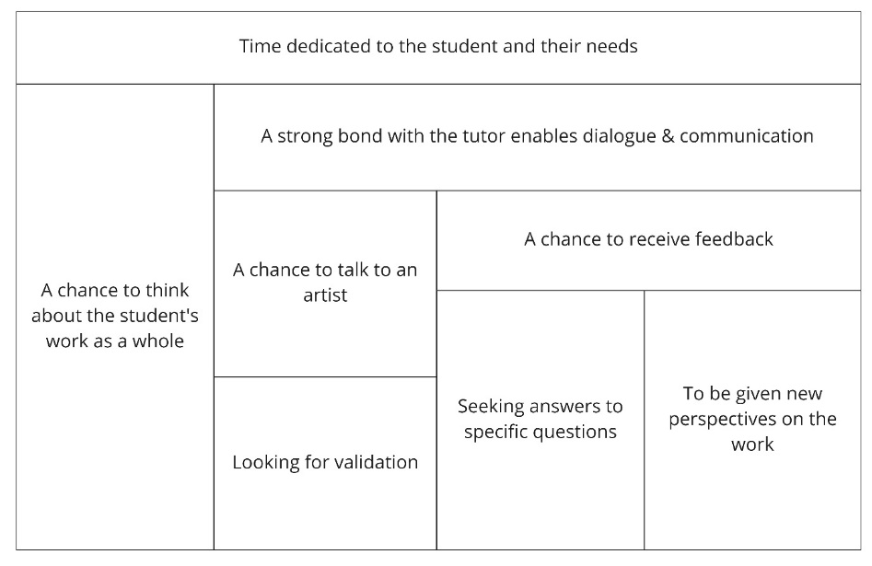
Figure 1: Outcome space for students’ perceptions of what makes a successful tutorial.

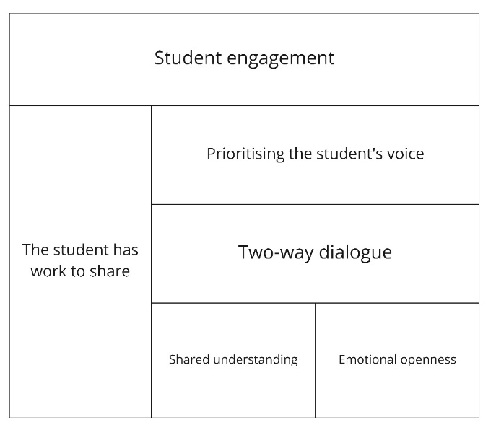
Figure 2: Outcome space for Lecturers’ perceptions of what makes a successful tutorial.

The two diagrams above represent student (Fig 1) and staff (Fig 2) perceptions of what makes a successful tutorial within undergraduate Fine Art at NUA. Given in response to two prompts during the structured interviews, they can be interpreted as encompassing both what attitudes or circumstances need to be in place to enable a successful interaction, and what sort of outcomes need to transpire in order to consider a tutorial successful. They are then a combination of expectations and ideals.
Moving downwards from the top of each diagram each description can be thought to be dependent on the existence of the one directly above it, and in this way it is possible to read variation in the range of attitudes and perceptions. In Fig 1 for instance, everything is dependent on there being time dedicated to the student and their needs. That is a basic precondition for success. But if there is also a strong bond with the tutor which enables dialogue, then there may be a chance to receive feedback on the artwork discussed. This cannot happen without the presence of dialogue.
Lecturers and students share perceptions of outcomes
Although this was a small-scale study of just ten tutorials, there was a high level of agreement between students and staff about the overall efficacy of the tutorial encounter. In eight out of ten instances the lecturer and the student were left with similar feelings, mostly feelings of success (‘It’s definitely impacted on what I’m going to be doing’). There was just one striking example where the retrospective perceptions of student and lecturer diverged significantly, with the lecturer hoping that ‘it will be productive for her’ while the student rejected the advice suggested, saying later in interview that ‘I’m very stubborn with my ideas’. During this particular tutorial the student responded to many suggestions with unsmiling nods, nonverbal noises and single-word answers. But she did not feel able to articulate her rejection more forcefully, perhaps leaving the lecturer with the impression that it had gone well.
Aside from this example however there was a strikingly high level of congruence in student and lecturer perceptions after the fact. This suggests that in the main lecturers should trust their feelings about whether a tutorial has gone well or not.

Dialogue and communication
Looking for similarities between the two outcome spaces it is clear that this notion of dialogue and communication is the most significant area of agreement. For the staff this is built upon student engagement and prioritising the student’s voice. From the student’s point of view, the key thing is a strong bond with the lecturer, and it is dependent on time being dedicated to the student and their needs in particular.
It’s really important that the student is heard. They have your attention for the whole time. So it should be a space they can raise things they couldn’t in a group, they should open up to me.
I think you want a dialogue and a balance. So the student doesn’t feel like they’re receiving wisdom in a passive way.
It’s the communication, definitely. It’s the bridge of communication when you have formed a bond with your tutor and you then feel comfortable. At the end of the day they are there to sit and talk to you whenever you need it and for as long as you need it about your work.
Continuity is crucial. If you don’t have the same tutor they don’t know your work.
This asymmetry might be understood by considering that a student only has one main relationship with their allocated tutor and therefore the strength of this relationship is going to be crucial to facilitating a good quality dialogue. Although students at NUA are taught by several staff over the course of a single year, they tend to have one-to-one tutorials with just a single named lecturer. The lecturer may have a large number of students in their tutor group, and of course this is just one year of many over the span of an unfolding teaching career. From the lecturer’s point of view then, the emotional bond with a student is conceptualised more abstractly as prioritising the student voice, listening to them speak. There is inevitably less of an affective connection.
The emphasis on dialogue rather than simple transmission of knowledge paints the lecturers in this study as ‘liminal servants’, if we are going to use the three roles described above (Webster 2004; McLaren 1988). The lecturers in this study all placed good communication with the student above the mechanical transmission of subject knowledge. In contrast to Webster’s study, in this instance the Fine Art students reciprocated in also seeing their tutors in this manner. In fact, it is interesting to observe that disciplinary knowledge per se does not even feature in the lecturer’s perceptions of what makes for success in Fig 2.
Chance to receive feedback
The most common-sense model of a tutorial is perhaps to see it as an opportunity to receive feedback and to have questions answered, and these elements came across strongly in the students’ perceptions. These might be very specific questions about what work needed to be submitted, how to cite a reference, or much more general questions about how to proceed. This is perhaps where the lecturer’s subject knowledge referred to above comes in. It is there implicitly in their ability to answer specific questions, make aesthetic judgements and suggest how to usefully proceed. In addition to answering student questions the other significant description of feedback from the student point of view was to say that it offered new perspectives on their work.
It helps to make you think about things in a different way, to take a different angle.
In the past my tutor has picked up on themes that I’d not recognised myself. That can help to bring awareness where some was lacking.
They gave me new information and put things in a different light.
This closely reflects the historic idea of the tutorial as a space to be used to facilitate the development of new insights in the student (University Grants Committee 1964). This is probably the description closest to an understanding of teaching as the construction and organisation of knowledge within the student. It resembles the third conception defined in Paul Ashwin’s study of the Oxford tutorial which sees tutorials as ‘the tutor bringing things into relation to each other to help the student develop a new perspective in the wider context of the discipline’ (Ashwin 2005: 638). In this example the student is describing a rough video that shows very close-up images of the freckles and tattoos on her own skin:
STUDENT: I think I prefer it as it’s getting more distorted because I find myself noticing little things that are happening on the screen because they’re disconnected from a thing. Like little marks that I wouldn’t think about before. My mind’s trying to make connections of what it could be, or… you know. Though obviously I know that it’s my arm.
LECTURER: At some point it starts to become like a landscape, where you start to get the tattoo coming in as well, so it subverts itself into something that it’s not. Not only it is kind of unknown, but it’s pretending as well.
Sometimes this change in perspective involved translating the student’s ideas or words into the idiomatic language of fine art and speaking it back to them. But this also suggests a further dimension involving the importance of the lecturer’s identity as an artist.
Chance to talk to an artist and receive validation
This final category was the most unexpected and interesting insight into the staff-student relationships that are played out in the tutorial situation. Published analysis of group crits in art and design had focused heavily on the affective experience of the students, specifically on the anxieties attendant on making yourself vulnerable when presenting artwork for public critique (Blair 2006: Day 2012). I therefore included a question on emotions in my interviews with both students and staff. There were however no notable trends in response other than a little mild anxiety (sometimes brought on by the presence of an observer) - for most participants the individual tutorial seems to be a relatively emotionally stable experience.
What did emerge was the importance of being able to talk to another artist, and the way that those conversations could have a validating effect on the student’s work. Students could receive confirmation from within the art world that they were working along the correct lines.
Having a one-to-one conversation with someone who has experience of the industry and of being an artist themselves.
Talking to another artist.
Rather than looking for answers to specific questions, or having something clarified, the important thing was that the lecturer was in a position of authority by virtue of being a practicing artist. Crippa (2015) and Percy (2004) suggest that there appears to be a social function in the way that receiving affirmation from an insider validates the student’s ideas and brings them gradually into the community of practice.
LECTURER: So you’re meeting the group this Friday?
STUDENT: In the morning. I was hoping that with the stuff I learn with that, I can incorporate that into the event that me and my mates are going to do in March.
LECTURER: Send me the date for that, I’ll try and get to see it. It’s brilliant that you’re doing that. Make sure that you document everything really carefully, not just as a record for yourself, but often in documenting the work sometimes it can reveal new avenues for the work, sometimes it becomes the work, or an alternative set of work. But that sounds really good and I’m impressed that you are all meeting as a group.
This relationship parallels the dynamics of the art market that Louisa Buck describes in her Arts Council publication Market Matters (2004). The key concept she describes is that of ‘validation’, which occurs when an artist is exhibited in a gallery, written about in the art press, awarded a commission or even a prize. The institutions of the art world have the tacit authority to confer approval (and consequently financial value) on an artist by virtue of their insider status, and this approval grows step by step from lesser to more significant national and international institutions as a consensus is gradually established. There are also parallels with the community of practice model (Lave & Wenger 1991) by which outsiders are gradually able to become insiders as they encounter and participate in informally approved spaces and activities. What was interesting to me was that this validation-seeking seemed to have an affective aspect to it. Approval from an artist/lecturer was significant in terms of what might be called identity transformation (Mezirow 2000) and not only because they might be a source of information. It was an opportunity to be seen and perceived as an artist rather than a student.
What prevents a successful tutorial
In many ways, it is simply the case that if the elements described above are missing then a tutorial might fail to be worthwhile for staff and/or student. But there were a few notable differences in the reported perceptions from each point of view.

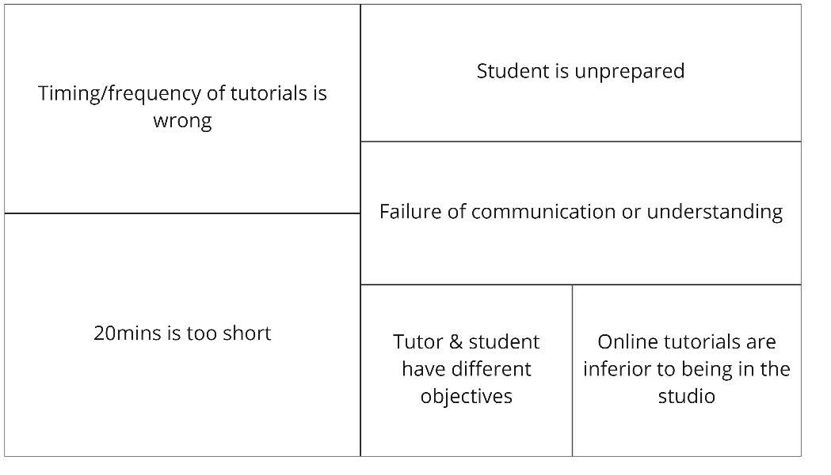
Figure 3: Outcome space for students’ perceptions of what gets in the way of a successful tutorial.
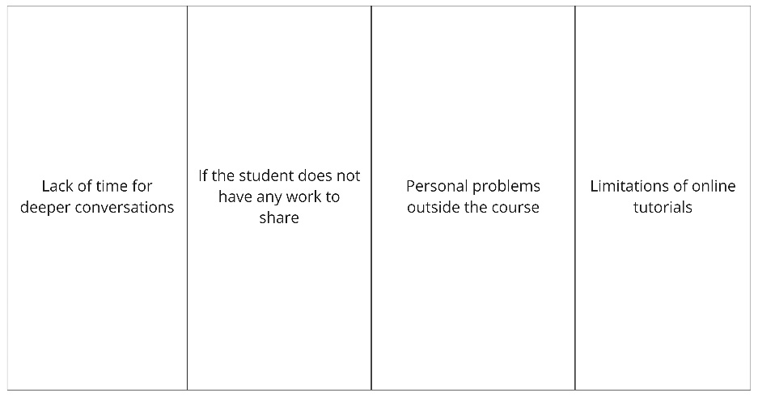
Figure 4: Outcome space for staff perceptions of what gets in the way of a successful tutorial.

Almost all participants raised the issue of a lack of time for deeper discussion. Twenty minutes was not considered long enough to explore content in any great depth, or to cover the range of subjects that a lecturer might wish to check in with a student about: anything from correct citations or attendance to the best way to document a piece of performance art. Several staff also mentioned the mental fatigue of delivering a day of back-to-back tutorials without time in between to write up notes or switch mental gears between students.
Often back-to-back tutorials, so no time to decompress or prepare.
Twenty minutes, back-to-back with no time to write up any notes. As an Hourly Paid Lecturer that's a huge amount of work. Also it's hard to get into the listening zone.
Too much of a rush. Barely had time to think & breathe. Sometimes you need to go a bit deeper into things.
From the student’s point of view another question was the correct timing of a tutorial. They might be too frequent so that there is nothing new to say or be scheduled at a point when the student is not yet able to talk about their creative work. The overlapping of institutional and personal cycles of productivity poses obvious problems when it comes to scheduling, and it was interesting that some students were cognisant of this.
Limitations of online tutorials
As mentioned above, this study was not originally designed to investigate the differences between online and in-studio tutorials. By the Autumn of 2021, over one year into the covid-19 pandemic in the UK, staff and students had become quite used to meeting online and the general feeling was that it was a reasonable compromise for one-to-one conversations. However both students and staff mentioned the limitations of not being in the room with artwork when it came to fine visual analysis, and the occasional technical frustrations of low-bandwidth or a bad connection. In almost all cases the lecturers had been able to see student work in real life in advance of the tutorials by walking around the studios, and this helped to mitigate the loss of physical presence to some degree. Students would share images of work by posting JPEGS into the chat or sharing screens. In some cases they would hold works up in front of the camera (with variable success) or even give a tour of their studios by walking from painting to painting with their smartphones. Using these kinds of strategies it was still possible to have meaningful and helpful conversations about all varieties of physical artwork through the mediation of the computer screen.
Based on my own twenty years of teaching fine art, and shorter experience of giving online tutorials to postgraduate students, I would make a few observations of the limitations of digital for future research. There is inevitably a tendency to talk about concepts and subject matter rather than materiality, formal qualities, or the fine nuances of ‘touch’. There was also significantly less work discussed and shared just by sheer quantity. Thirdly, the focus of the conversations tended to be led by what the student wanted to show, and the lecturer did not have the opportunity to move the conversation on to a sketch pinned up on the wall, a sheaf of drawings hidden in a portfolio, or a sculpture tucked under a table. There was far less ground covered, in other words, and less opportunity to identify good work that the student had perhaps undervalued. Finally, it was clearly next to impossible to make points experientially, to work with the body or to inhabit a space together in a way that is sometimes useful in discussions of sculpture and installation work. In my view these are clear limitations of the digital tutorial, although see the earlier discussion of the place of the tutorial within the taught programme above.
Conclusions
Within the parameters of this study it is clear that staff and students value the one-to-one tutorial highly. It is an important and traditional pedagogic tool that has its roots in the academies and workshops of the Renaissance and still serves a slightly ritualised purpose today in terms of bringing students into a wider community of practice. It was encouraging to see that almost all participants agreed about the nature of the outcome which suggests that there were no radically divergent perspectives encountered within this particular course community. The conversations were generally open, transparent and honest. There was also a very strong agreement about the importance of dialogue, open communication, and the role of the personal bond between staff and students. Without this dialogue it is difficult to fulfil any more specific student expectations. This was in stark contrast to Webster’s findings in 2004, where a cohort of architecture students saw their tutors very much as coercive Hegemonic Overlords who would tell them what to do and not engage in authentic conversations. The differences between the two studies precludes drawing causative conclusions from this, but it is still pleasing to see a student-centred approach coming to the fore, which very much follows the explicit principles of course design at NUA.
While tutorials did not seem to generate the anxieties and fear that have been reported in relation to group critiques (Day 2012; Ashwin 2005), perhaps because of their inherently private nature, there was a surprising affective dimension evident in the form of the student’s desire for validation by an authentic member of the art world. Being seen as an artist by an art world insider was a significant part of the formative feedback and could perhaps be seen in terms of transformative learning (Mezirow 2000). It meant that the work under consideration, sometimes the whole approach to creative practice, or even the student themselves as a person, was receiving approval from a source of disciplinary authority. This process also foreshadows the concept of institutional validation that has been identified as central to the workings of the professional art world (Buck 2004) and supports Salazar’s finding that students thought ‘the best professors were those who treated them as “fellow artists” and “equals”’ (Salazar 2014:35). In order to play their part in this dynamic effectively it is therefore necessary for lecturers to maintain an active and visible creative practice, and to be aware that the answers they give to student queries may in fact be less important to the student than the fact that they are being taken seriously at all. It would be interesting to see if this dimension was also present in other more design-based disciplines, or whether it is limited to the often-subjective and personal creative discourses of fine art.

References

Ashwin, P (2005) 'Variation in students' experiences of the Oxford tutorial.', Higher Education, vol. 50, no. 4, pp. 631-644.
Blair, B. (2006), “At the end of a huge crit in the summer, it was “crap” – I’d worked really hard but all she said was “fine” and I was gutted.”, Art, Design & Communication in Higher Education 5: 2, pp. 83–95
Buck, L (2004) Market Matters: The dynamics of the contemporary art market. London: Arts Council England
Crippa, E (2015) From ‘Crit’ to ‘Lecture-Performance’, in Llewellyn, N (2015) The London Art Schools: Reforming the Art World, 1960 to Now. London: Tate pp. 133-150
Day, P (2012) The art group crit: how do you make a firing squad less scary? Available at http://arts.brighton.ac.uk/projects/networks/issue-18-july-2012/the-art-group-crit.-how-do-you-make-a-firing-squad-less-scary (Accessed: 1 April 2021)
Elkins, J (2001) Why Art Cannot Be Taught. Urbana and Chicago, University of Illinois Press
Goldschmidt, G., Hochman, H., & Dafni, I. (2010). The design studio ‘crit’: Teacher-student communication. Artificial Intelligence for Engineering Design, Analysis and Manufacturing, 24(3), 285-302.
Goldstein, C (1996) Teaching Art: Academies and Schools from Vasari to Albers. Cambridge University Press
Lave, J. and Wenger, E. (1991) Situated Learning: legitimate peripheral participation. Cambridge University Press
Mezirow, J ed. (2000) Learning as Transformation. San Francisco: Jossey Bass
McLaren, P (1988) ‘The Liminal Servant and the Ritual Roots of Critical Pedagogy’ in Language Arts, Feb 1988 Vol 65 No 2. Classroom Interaction as Teaching and Learning, pp. 164-180
Orr, S et al (2014) ‘The answer is brought about from within you’: A Student-Centred Perspective on Pedagogy in Art and Design. International Journal of Art & Design Education. 33.1 Feb, pp. 32-45
Orr, S and Shreve, A (2017) Art and Design Pedagogy in Higher Education: Knowledge, Values and Ambiguity in the Creative Curriculum. Routledge Research in Higher Education
Percy, C. (2004) ‘Critical absence versus critical engagement. Problematics of the Crit in design learning and teaching’, Art, Design and Communication in Higher Education, 2(3) pp.143-54.
Salazar, S (2014) ‘Educating Artists: Theory and Practice in College Studio Art’, Art Education. 67(5):32-39
Schön, D (1982) The reflective practitioner: How professionals think in action. New York: Basic Books.
Schön, D (1984) The architectural studio as an exemplar of education for reflection-in-action. Journal of Architectural Education, 38(1), 2-9.
Subri, D (2017) Students’ Experience of Identity and Attainment at UAL. Centre for Public Policy Research: King’s College London
University Grants Committee (1964) Report of the committee on University teaching methods (The Hale Report) London, HMSO
Webster, H (2004) Facilitating critically reflective learning: excavating the role of the design tutor in architectural education. Art, Design & Communication in Higher Education 2 (3) pp. 101-111

